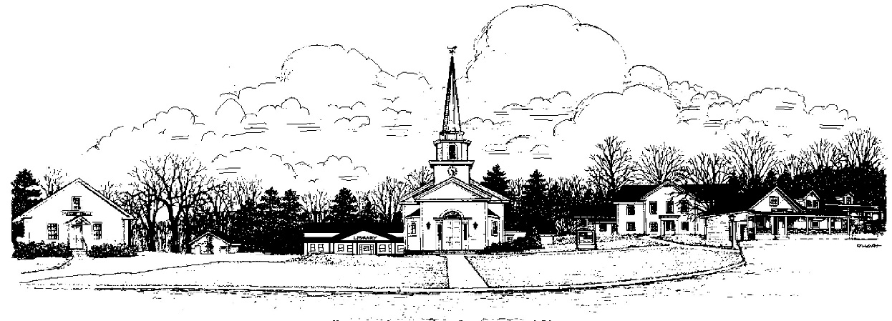
Town of
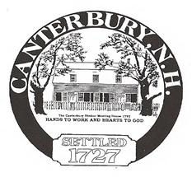
Canterbury, New Hampshire, Settled 1727

Procedure for Class VI or Private Road Waiver

- Application packet will contain:

- The Application to Build
- The Agreement and Release
- The Road Upgrade Agreement
- Copy of the Class VI/Private Road Policy
- The applicant will fill out the application and the agreement and turn in to the Town.
- The Road Agent will coordinate with the Fire Department, Police Department, Building Inspector and applicant for a site visit.
- Comments will be added to the appropriate areas of the application.
- The Road Agent will coordinate with the applicant for any required upgrades which will be listed on the “Road Upgrade Agreement”.
- The completed packet will be forwarded to the Planning Board for comments.
- The Board of Selectmen will review the packet and sign.

