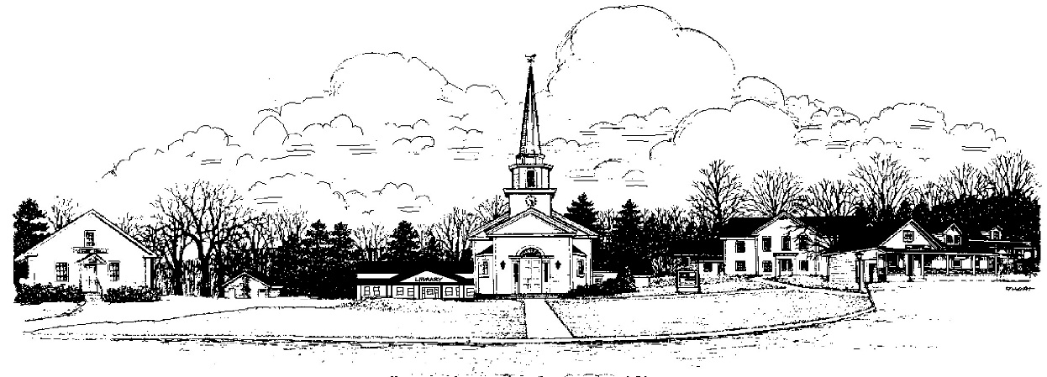
Town of
Canterbury, New Hampshire, Settled 1727

RSA 674:41 Application to Build on a Class VI Highway or Private Road

Property Owner: Date:
Property Owner Signature(s):
Mailing Address:
Phone #: E-Mail:
Location: Tax Map #: Lot #:
Road Name:
*****All applications must include the following information*****

- The location and size of the lot and its relation to the Class VI or Private Road and the Class V or better road which gives access to the Class VI or Private road; and

- The specific location of all propose structures as required by the building application; and

- The location and length of driveway giving access to the structures from the Class VI or Private Road; and

- If wetlands exist; wetlands delineation, by a certified wetlands scientist on the subject property or adjacent property that could be impacted, and indication whether a State Wetlands Permit has been submitted; and

- A written road maintenance agreement if there is one party residing on the road, or the applicant agrees in writing to assume 100% of the road maintenance costs for the portion of Class VI or Private Road affected. Applicant shall address the need for a potential turnaround for emergency vehicles in order to avoid or eliminate a dead end road.

RSA 674:41 Application to Build on
a Class VI Highway or Private Road

Is a Class VI Highway, provided that:
- The Selectmen, after review and comment by the Planning Board , has voted to authorize the issuance of the building permit for the erection of building(s) on said Class VI Highway or a portion thereof per their adopted procedures; and

- The Municipality neither assumes responsibility for maintenance of said Class VI Highway nor liability for any damages resulting from the use there; and

- Prior to the issuance of a building permit, the applicant shall produce evidence that notice of the limits of Municpal responsibility and liability has been recorded in the County Registry of Deeds.

Is a Private Road, provided that:
- The Selectmen, after review and comment by the Planning Board , has voted to authorize the issuance of the building permit for the erection of building(s) on said Private Road or a portion thereof per their adopted procedures; and

- The Municipality neither assumes responsibility for maintenance of said Private Road nor liability for any damages resulting from the use there; and

- Prior to the issuance of a building permit, the applicant shall produce evidence that notice of the limits of Municpal responsibility and liability has been recorded in the County Registry of Deeds.

SA 674:41 Application to Build on
a Class VI Highway or Private Road

Name:

Map & Lot:

Building Inspector:

Signature: Date:

Comments:

Planning Board:

Chairman Signature: Date:

Comments:

Fire Chief

Signature: Date:

Comments:

Police:

Signature: Date:

Comments:

Road Agent:

Signature: Date:

Comments:

Board of Selectmen

Signatures:

____________________________________ Date:

____________________________________ Date:

____________________________________ Date:

Comments:

