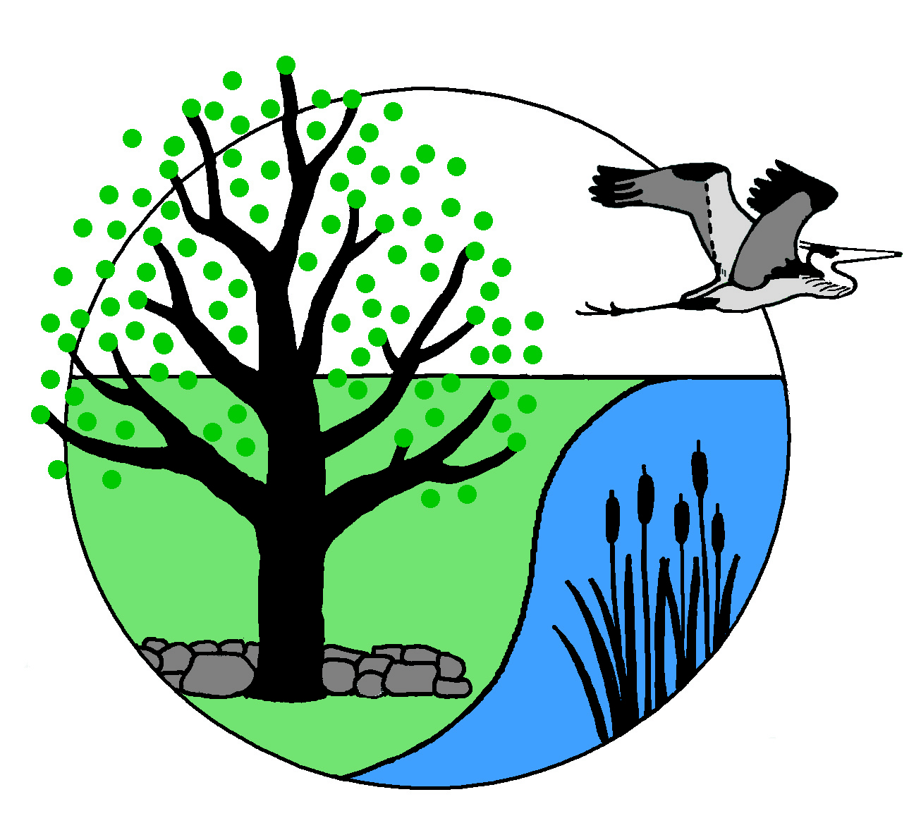Canterbury Conservation Commission
Meeting Minutes – August 12, 2019 DRAFT
Members Present: Tom Osmer (Chair), Ken Stern (Vice Chair), Steve Seron, Kelly Short, Charlie Krautmann,
Absent: Chris Blair, Bob Steenson , Bob Fife, Linda Fife, Teresa Wyman.

This meeting was a site walk of the Sawyers Ferry Conservation area. No business was transacted.

The commission met at the Center at 6:30, drove to the property, walked the property returning at 8 pm.

Respectfully submitted, Ken Stern

